|  |  |  |  |  |  |  |  |  |
| --- | --- | --- | --- | --- | --- | --- | --- | --- |
|  | Abir || 18BCS2471 || CSE-16-(B) PTHON LAB EXPERIMENTS | | | | | | | |
|  |  |  |  | | | | |  |
| Sr no. | Experiment Name | Date | | MarkingC P V T | | | | Teacher Sign |
| 1 | Write python programs in various modes and printing and assigning values assigned to the variables. |  | |  |  |  |  |  |
| 2 | Program to demonstrate the use of if, if else, while, for, break and continue. |  | |  |  |  |  |  |
| 3 | Program to demonstrate the use of functions and passing different types of arguments to functions. |  | |  |  |  |  |  |
| 4.1 | Using recursive and non-recursive functions , write a python program to find factorial of a given number. |  | |  |  |  |  |  |
| 4.2 | Display all the employee details . Also calculator the yearly income tax of employee based on a prevailing income tax slabs. |  | |  |  |  |  |  |
| 5.1 | To write a python program to find the maximum, minimum , mean ,median and mode for a list of numbers using user defined functions. |  | |  |  |  |  |  |
| 5.2 | To write a python program to multiply matrices. |  | |  |  |  |  |  |
| 6.1 | Write a program to count the number of characters in the string and store them in a dictionary data structure. |  | |  |  |  |  |  |
| 6.2 | Write a program to combine_listes that combines these lists into a dictionary. |  | |  |  |  |  |  |
| 7.1 | To write a python program to find the most frequent words in a text read from a file. |  | |  |  |  |  |  |
| 7.2 | Program to print each line of a file in reverse order and to compute the no. of char. , words and lines in a file. |  | |  |  |  |  |  |
| 8.1 | Write a function nearly test whether to strings are nearly equal. |  | |  |  |  |  |  |
| 8.2 | Write a function dups to find all duplicates in a list. |  | |  |  |  |  |  |
| 9.1 | Program to :  1. Read a file.  2. add (\) before every double quotes in the file contents.  3. write it to another file in the same folder.  4. print the contents of both the files |  | |  |  |  |  |  |
| 9.2 | Python program to count the words in the file using dictionary. |  | |  |  |  |  |  |
| 10 | Python program that reads a text file, scrambles the words in file on following rules and writes the output to a new text file. |  | |  |  |  |  |  |
| 11 | Demonstration of class variables and instance variables and illustrations of the self-variables using an application of ATM machine. |  | |  |  |  |  |  |
| 12 | Build any classical data structure viz. stack or queue using object-oriented python. |  | |  |  |  |  |  |

Experiment 1:

Write python programs in various modes and printing and assigning values assigned to the variables.

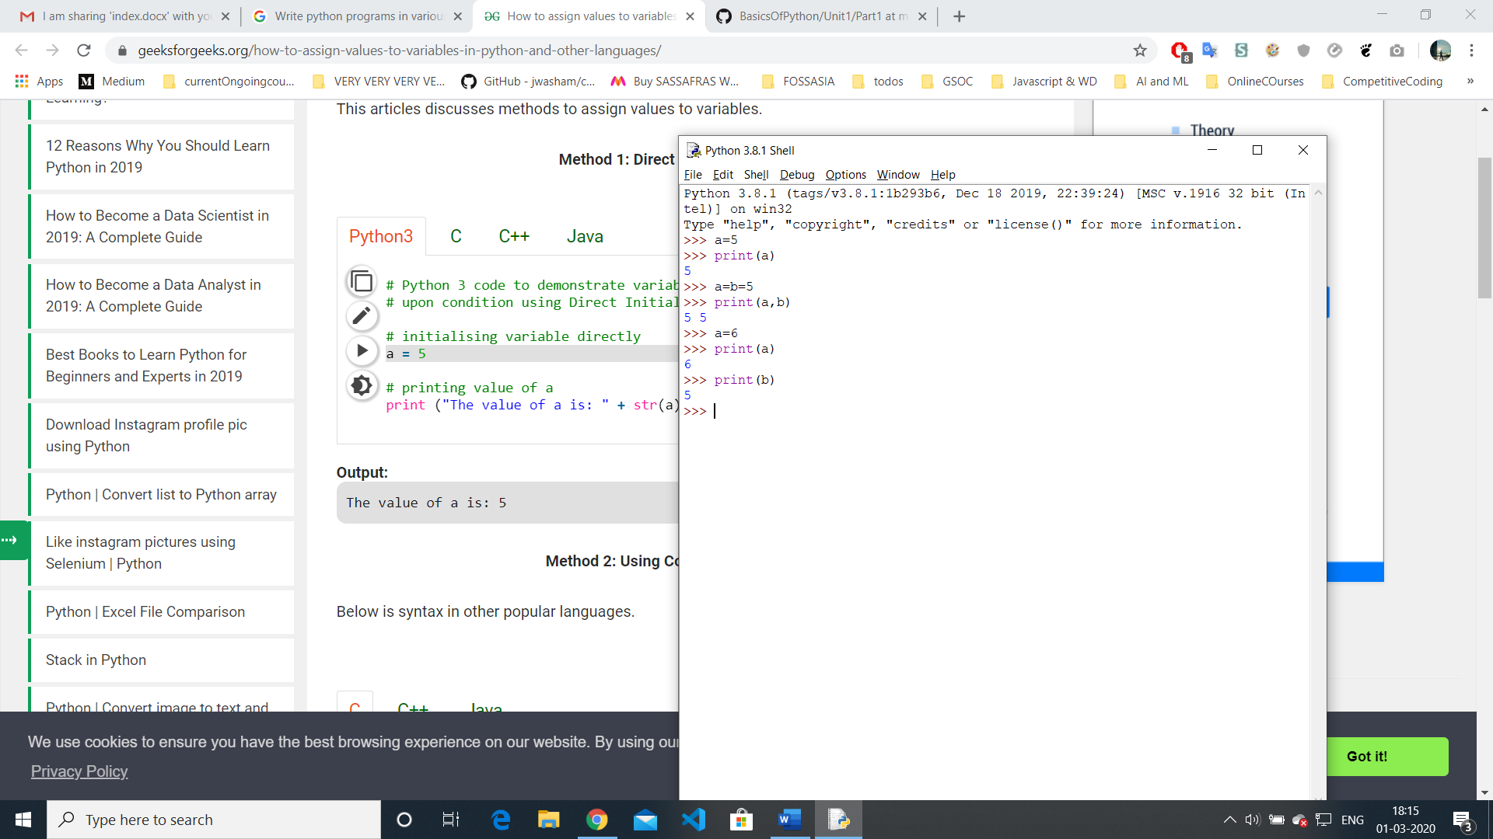

Result:

Successfully implemented python programs in various modes and printing and assigning values assigned to the variables.

Experiment 2:

Program to demonstrate the use of if, if else, while, for, break and continue.

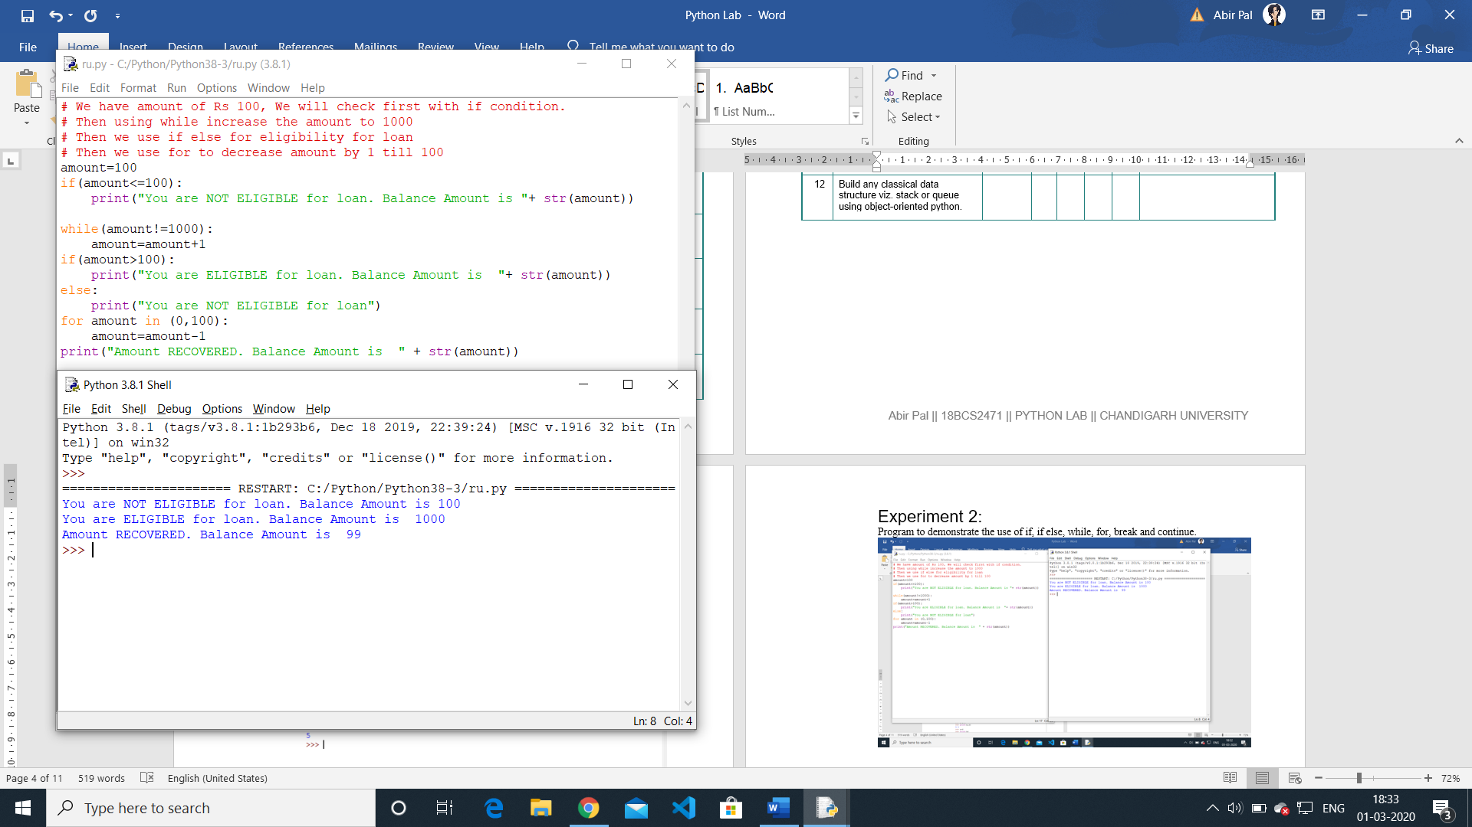

Result:

Successfully implemented Python program to demonstrate the use of if, if else, while, for, break and continue.

Experiment 3:

Program to demonstrate the use of functions and passing different types of arguments to functions

Experiment 4.1:

Write python programs in various modes and printing and assigning values assigned to the variables

Experiment 4.2:

Write python programs in various modes and printing and assigning values assigned to the variables

Experiment 5.1:

Write python programs in various modes and printing and assigning values assigned to the variables

Experiment 5.2:

Write python programs in various modes and printing and assigning values assigned to the variables

Experiment 6.1:

Write python programs in various modes and printing and assigning values assigned to the variables

Experiment 6.2:

Write python programs in various modes and printing and assigning values assigned to the variables